All Interfaces Picture of UUM Student Satisfaction Analysis Monitoring Tool (UUMSSAMT) in High Quality (Screenshot)
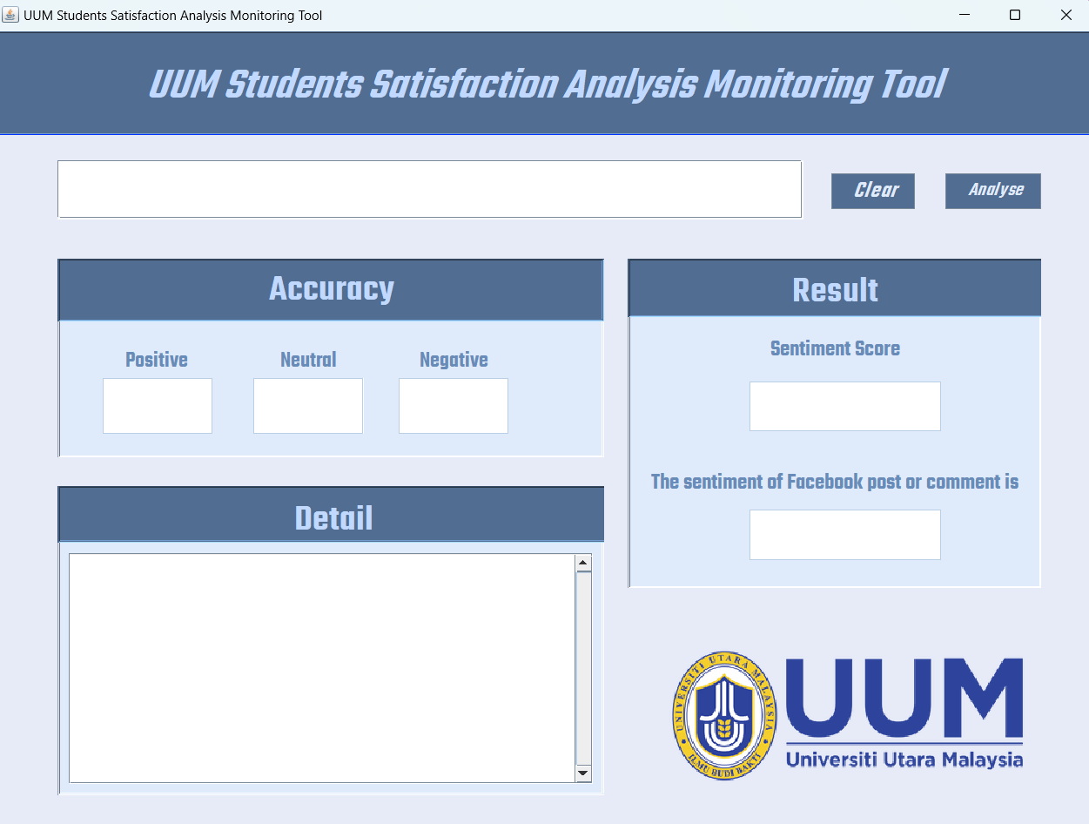
Figure 1: UUMSSMAT Before Sentiment Analysis

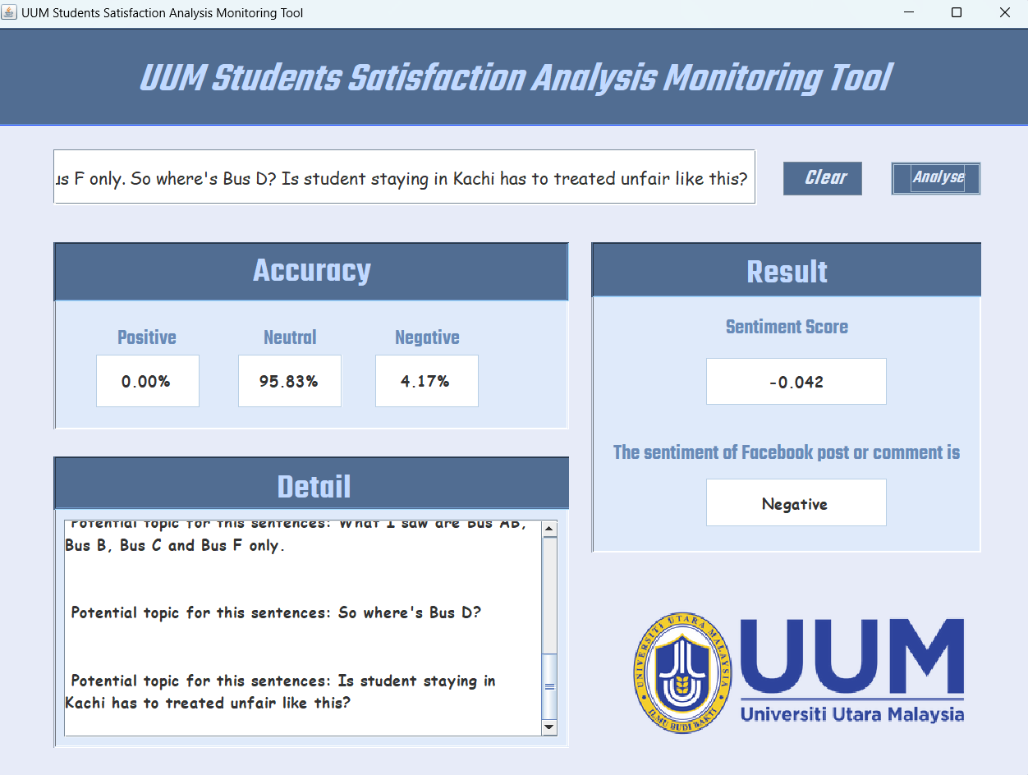
Figure 2: UUMSSMAT After Sentiment Analysis (Result: Negative Sentiment)
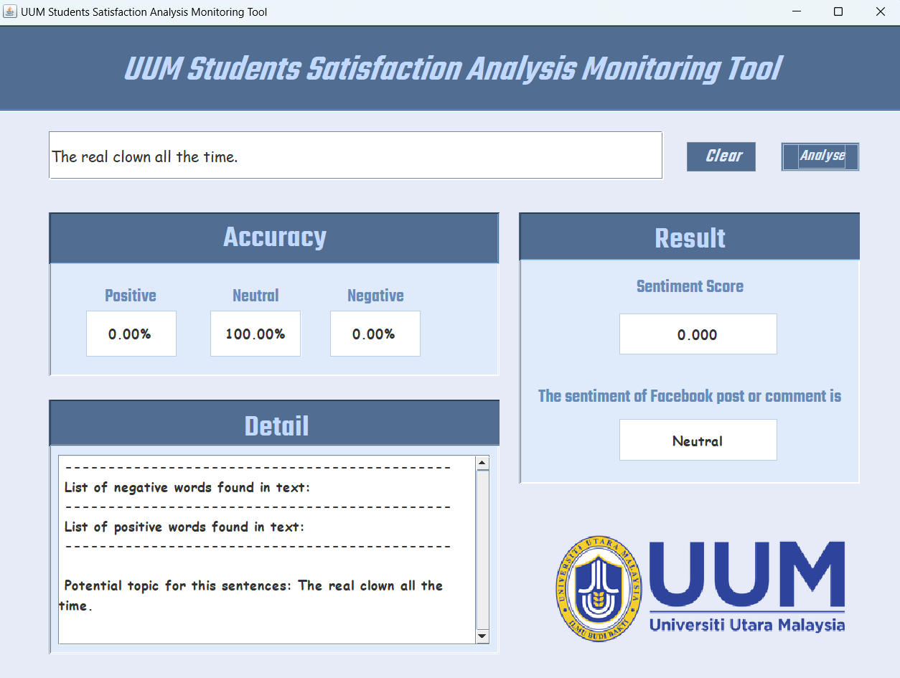
Figure 3: UUMSSMAT After Sentiment Analysis (Result: Neutral Sentiment)
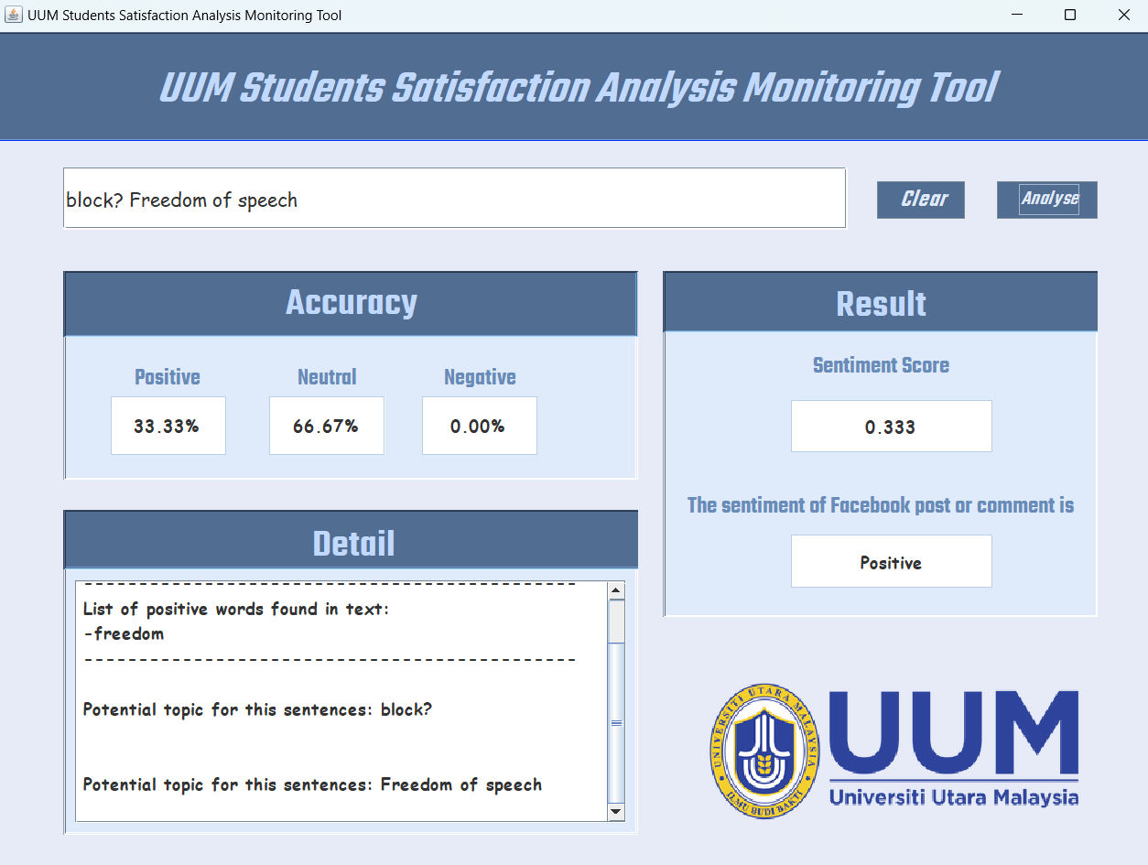
Figure 4: UUMSSMAT After Sentiment Analysis (Result: Positive Sentiment)

